

Study Guide to Alexander Strauch’s Biblical Eldership

Chapter 1: New Principles for Leadership
Read Chapter 1: “New Principles for Leadership”
Introduction: This chapter considers Jesus’ teachings about leadership and His example of humble service.
Q: Jesus did not merely talk about leadership—He modeled it (John 13:3–5, 12–15). What specific lessons about leadership do we learn from His example?
Answer Here
Q: Strauch examines Jesus’ teachings on servant leadership (Mark 9:33–37; 10:32–45; Luke 22:24–27; Matthew 23:1–12). What principles do these passages teach about leadership in God’s kingdom?
Answer Here
Q: Strauch writes, “Jesus’ most severe denunciations were directed at the religious elite of his day” (p. 27). What do His critiques of the religious leaders teach us to avoid in our own leadership and lives?
Answer Here
Q: Much of this chapter comes down to pride versus humility. What practical steps can we take to guard against pride? What can we do to cultivate humility?
Answer Here
Q: Strauch writes this about Diotrephes: “He represents all those who abuse their pastoral authority” (p. 29). What lessons can we learn from his negative example (3 John 9–10)?
Answer Here
Q: How would you define the biblical concept of servant leadership?
Answer Here
Application: In light of this chapter, what specific steps should you take to prepare yourself for the office of elder?
Answer Here

Study Guide to Alexander Strauch’s Biblical Eldership

Chapter 2: Pastoral Leadership
Read Chapter 2: “Pastoral Leadership”
Introduction: This chapter considers the meaning and responsibilities of pastoral leadership.
Q: Strauch explores the shepherd imagery found in Scripture. What does the Bible teach about sheep and shepherds, and how does this inform pastoral ministry?
Answer Here
Q: Strauch writes, “Love is indispensable to all you say and do as a shepherd leader” (p. 33). Why is love so essential to pastoral ministry?
Answer Here
Q: What is involved in teaching—feeding the flock (Jeremiah 3:15)? How should faithful shepherds feed the sheep? What happens to churches when elders neglect this responsibility?
Answer Here
Q: What is involved in protecting the flock (Acts 20:28–31)? What dangers must the flock be guarded against? How do elders fulfill this responsibility? What happens to churches when elders neglect it?
Answer Here
Q: What is involved in leading the flock (1 Timothy 5:17)? In other words, what does it look like in real life to rule, govern, and oversee the flock? What happens to churches when the elders neglect this responsibility?
Answer Here
Q: What is involved in caring for the flock (1 Timothy 3:4–5)? Why must elders spend personal time with people? What happens to churches when elders neglect this responsibility?
Answer Here
Q: What are tentmaking elders? What advantages do they bring to a leadership team?
Answer Here
Application: In light of this chapter, what specific steps should you take to prepare yourself for the office of elder?
Answer Here

Study Guide to Alexander Strauch’s Biblical Eldership

Chapter 3: “Shared Leadership”
Read Chapter 3: “Shared Leadership”
Introduction: This chapter shows that leadership in the church is a shared responsibility among a plurality of elders.
Q: How would you defend with Scripture the view of plural leadership in the church?
Answer Here
Q: How would you define shared leadership in the church?
Answer Here
Q: Explain Strauch’s line of reasoning. How does he defend the view of shared leadership in the church?
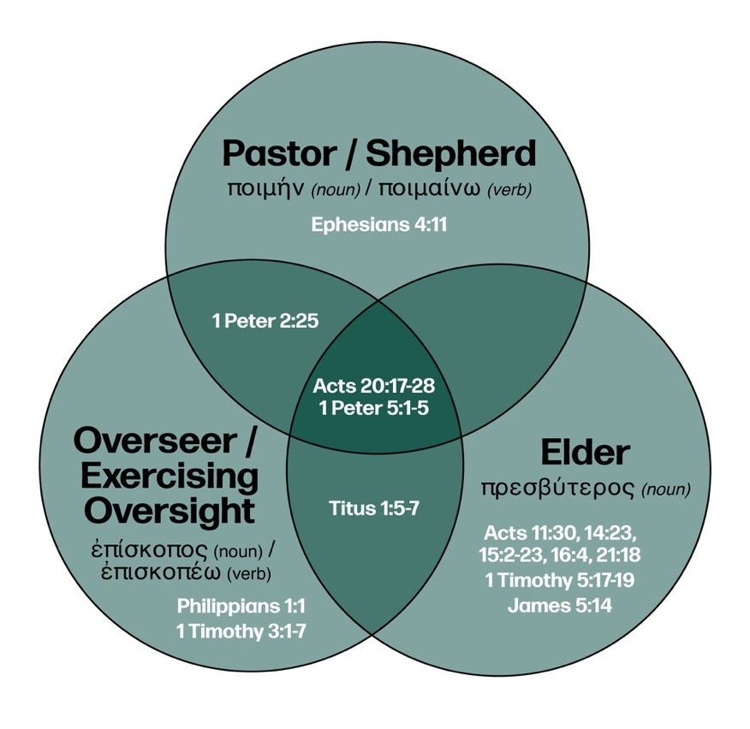
Answer Here
Q: Strauch writes about “A Mistaken Terminological Distinction” (p. 47). How does the accompanying graphic help correct some common misconceptions in the modern church about the office of elder?
Answer Here
Q: What are some of the benefits of shared leadership both for the leaders and for the church as a whole?
Answer Here
Q: Do you agree or disagree with Strauch’s critique of the one-pastor rule? Explain your view on this topic.
Application: In light of this chapter, what specific steps should you take to prepare yourself for the office of elder?
Answer Here

Study Guide to Alexander Strauch’s Biblical Eldership

Chapter 4: Qualified Leadership
Read Chapter 4: “Qualified Leadership”
Introduction: This chapter introduces the biblical teaching that spiritual leaders must meet specific, God-revealed qualifications.
Q: What should motivate elders to serve the church? Why do the motives of the heart matter in pastoral ministry?
Answer Here
Q: Later chapters will explore the qualifications in detail. This chapter, however, surveys the forest before examining the trees. Generally speaking, what stands out to you about the requirement lists (1 Timothy 3:1–7; Titus 1:5–9; 1 Peter 5:2–3)?
Answer Here
Q: Strauch writes, “One of the most common mistakes made by local churches is that they do not adequately examine candidates for eldership according to the biblical requirements” (p. 62). Why does this happen? What are the consequences when a church compromises on qualifications (1 Timothy 3:10)?
Answer Here
Q: What do we learn about pastoral ministry from the various terms used to describe church leaders (Titus 1:5–9) and their work (1 Peter 5:1–5)?
Answer Here
Q: What point is Strauch making in the section “Not Perfection or Sinlessness” (pp. 65–66)?
Answer Here
Q: Why does a man’s moral character matter in pastoral ministry?
Answer Here
Q: What abilities must elders possess to be biblically qualified? Why are these abilities essential for pastoral ministry?
Answer Here
Application: In light of this chapter, what specific steps should you take to prepare yourself for the office of elder?
Answer Here

Study Guide to Alexander Strauch’s Biblical Eldership

Chapter 5: Male Leadership
Read Chapter 5: “Male Leadership”
Introduction: This chapter addresses a controversial subject in the modern church—elders must be men.
Q: Strauch writes, “Yet nothing is more objectionable to the minds of many contemporary people than the biblical requirement of an all-male eldership” (p. 69). Why do people object to this requirement, and why should we continue to hold to it?
Answer Here
Q: What does it mean that men and women are equal in personhood, dignity, and value yet distinct in their gender roles?
Answer Here
Q: Strauch presents the model of male leadership by appealing to Jesus and the apostles as examples. He also addresses the objection that Jesus was merely accommodating His culture. How would you respond to this objection?
Answer Here
Q: Strauch develops his position from 1 Timothy 2:8–14; 1 Corinthians 11:2–16; 14:33–38; and Ephesians 5:22–33. How do you understand these passages, particularly as they relate to male leadership?
Answer Here
Q: According to Scripture, how are women involved in God’s plan of redemption and in the life of the local church?
Answer Here
Application: In light of this chapter, what specific steps should you take to prepare yourself for the office of elder?
Answer Here

