

Study Guide to Alexander Strauch’s Biblical Eldership

Chapter 3: “Shared Leadership”
Read Chapter 3: “Shared Leadership”
Introduction: This chapter shows that leadership in the church is a shared responsibility among a plurality of elders.
Q: How would you defend with Scripture the view of plural leadership in the church?
Answer Here
Q: How would you define shared leadership in the church?
Answer Here
Q: Explain Strauch’s line of reasoning. How does he defend the view of shared leadership in the church?
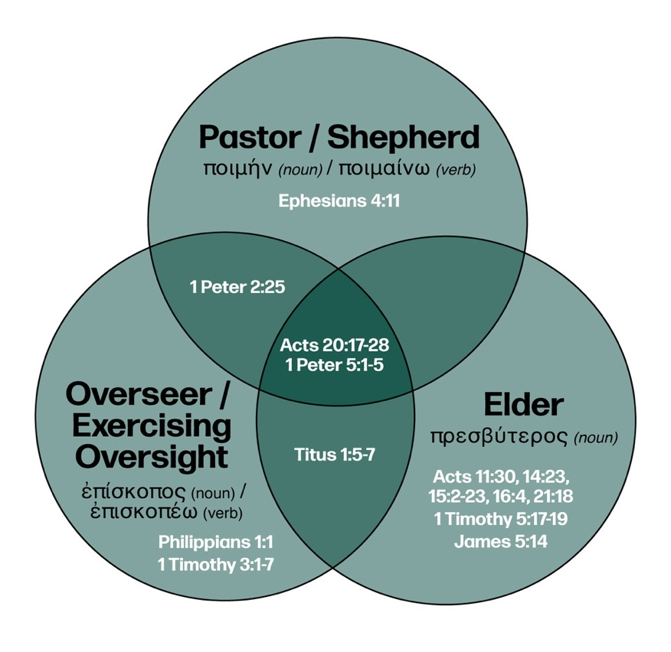
Answer Here
Q: Strauch writes about “A Mistaken Terminological Distinction” (p. 47). How does the accompanying graphic help correct some common misconceptions in the modern church about the office of elder?
Answer Here
Q: What are some of the benefits of shared leadership both for the leaders and for the church as a whole?
Answer Here
Q: Do you agree or disagree with Strauch’s critique of the one-pastor rule? Explain your view on this topic.
Application: In light of this chapter, what specific steps should you take to prepare yourself for the office of elder?
Answer Here

